EarthTides

Note:
Be sure to rifle through all of the packaging for
components of your new EarthTides.

1. Stainless Steel Plates (Wash with soapy water before use.)
2. Stainless Steel Probes (Wash with soapy water before use.)
3. One set of cables
4. Two Nylon bolts, nuts and spacers
5. The power cable
6. The black unit ‘EarthTides’

Setting the Amps (Lower Panel)
The amps on EarthTides should be at 5 Amps. It is easy to set and after you set it to 5 amps, EarthTides will remember this setting. Once set, this lower panel will measure the amps being used during the footbath. With one teaspoon of salt in the water, the display should show somewhere between 2.00 amps to 3.60 amps
1. Plug in EarthTides and turn it on. (The Power button is on the lower left hand corner.)
2. Press and release the lower right hand button (Current).
If the reading is 5.00 Amps, EarthTides is already set.

Note: Pressing and releasing either button
allows you to move through the digits.
A flashing digit indicates that it can be
modified by turning the button left or right.
The digit can be modified even after it stops flashing.

Follow these easy instructions to set the current to 5 amps.
1. Press and release the bottom button (Current) until the left hand digit is flashing.
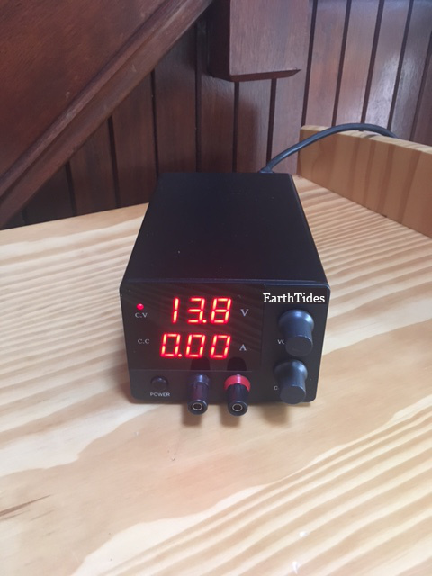
2. Set the number to ‘5’ by turning the button to the right. If the second and third digits are not zero, use the same method to set them to zero. You have now successfully set your EarthTides to 5 amps.
3. After a few seconds, all the numbers on the lower panel return to zero which is normal. The calibration will hold. Notice in this picture that the lower panel indicates 0.00 amps. As you begin using your EarthTides, the lower panel will indicate the number of amps being used. When you use the round probes as the zapper at 7.8 volts the Amp display remains at ‘0’ because only 4/1000 of an amp is being used while you use the micro-current device.
To check the amp setting at any time, simply press and release the lower right hand button.

Setting the Voltage (Upper Panel)
To use EarthTides as an ionizing body detox, set the voltage to 13.8 volts using the same method as above.
To use EarthTides as a micro-current device, set the voltage to 07.8 volts using the same method as above.
If either of these voltage settings is too uncomfortable, simply lower the settings. As an example, when the probes are used in the mouth for cavities or infections sometimes 7.8 volts can be to strong for some individuals. Lower the voltage to the point that you can feel the stimuation AND the stimulation is comfortable.
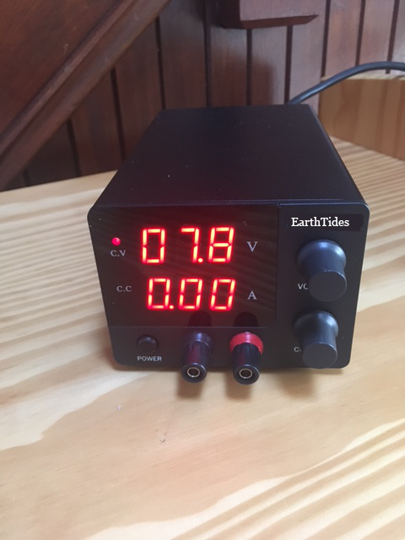
In regards to the footbath, sometimes children and sensitive individuals feel the foot bath to be uncomfortable. Lower the voltage to a comfortable level but be sure that bubbles are still being made in the water.
Note: When you turn off EarthTides,
it takes about 3 seconds to shut down.

Two Body Cleansing Technologies
in One Dependable Device

1. The Ionizing Body Detox helps the body release toxins, chemicals, pharmaceuticals, heavy metals.
2. The Micro-Current Device helps the body fight fungus, candida, bacteria, viruses and other pathogens. This micro-current device has also been useful in helping the body reduce/eliminate chronic pain in the joints, muscles and other parts of the body.

Safety
1. Safety is our number one concern. This device is safe and has many safety features. One teaspoon of salt is all you need. Never use a metal, copper or steel basin. Never arc or touch the flat plates together. If a fuse blows more than once or the auto circuit breaker continues to pause EarthTides, that means that something is not right. Turn off the device and check to be sure that the plates are not touching.
2. If you use a pacemaker, the chances that this device would reprogram it is very, very remote. There are a handful of natural herbs that you can use that help cleanse the body.
3. If you are pregnant, you may want to get professional advice about cleansing your body at this time using the ionic foot bath.
4. If you are taking medication to balance critical components of your body, you may want to consult a physician before you start cleansing with EarthTides. It will cleanse your body of chemicals and medications. Your physician may recommend a specific strategy for the use of EarthTides and the intake of your specific medication.
5. If the plates touch each other or if you arc the plates with metal, they will may spark and
EarthTides will pause until the plates are separated.
6. When you use the probes of the micro current device in your mouth, and you have metal amalgam fillings, which allegedly have mercury, which allegedly may be harmful to the physical body, be sure to spit out any saliva that accumulates in your mouth.

Ionizing Detox Instructions
Note: The ionizing body detox and the micro-current device are used separately. The one cable is used for both modalities.

1. Purchase a plastic or glass tub to fit your feet/arms. (Do not use copper or any metal tub)
2. Fill the plastic tub with about 2 ½ - 3 inches of water and one teaspoon of salt. DO NOT USE EPSOM SALT. Ionization is compromised and no hydroxides will be created using Epsom Salt. Any other salt with work but I like using Morten’s Canning and Pickling Salt because of it’s purity. Sea salt works, Himalayan salt works, Celtic salt works.
3. Plug EarthTides into a 120 or 240 volt outlet.
4. Plug the cables into the plates using the holes in back of the plates.
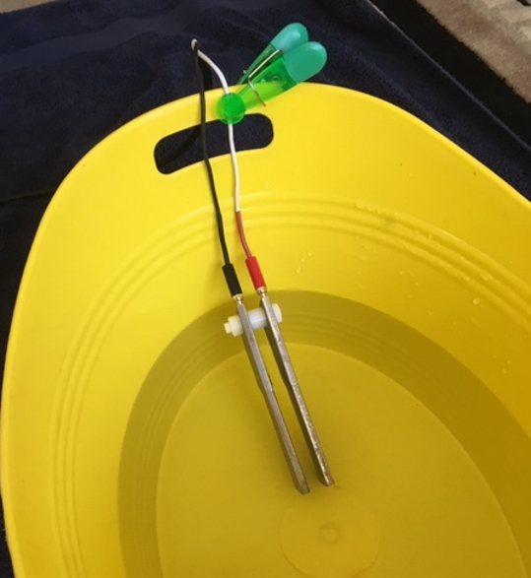
4. Put the plates into the water leaning them against the side as shown. You can use a clothes pin as a clip as shown so the banana plugs and nylon bolt stay out of the water. This protects them from early corrosion. The metal plates should be placed opposite the person whose feet are in the water. The water level after the person's feet are in the water should be just UNDER the nylon bolt and nut. A person can comfortably touch with arms or feet the plates in or out of the water while the unit is running.
5. Plug the other end of the cables into the front panel. The cable that is plugged into the black jack on the front panel is connected to the plate that will be oxidized during that session. Over time, one plate will get smaller. Remember to plug the cable of the larger plate into the Black jack on the front panel so that the plates wear out evenly over time. Eventually the plates wear out by getting rougher and smaller. Eventually the plates get so small that they are difficult to work with. It’s time to order another set. https://earthtides.net

6. Turn on the device using the switch at the front of the unit and watch how bubbles begin to flow from the metal plate that is connected to the cable that is plugged into the black jack on the front panel. Ionization is taking place and hydroxides are being created in the water. These hydroxides have a negative charge and they are neutralizing the positive charge on toxins, chemicals, heavy metals, pharmaceuticals, drugs and other anomalies in your body so they are no longer stuck and your body can now release them through the natural processes associated with urine, feces and sweat. The fan will turn on when you turn on the device. This is normal. It keeps the unit cool.

Note: We do not use color charts. For the most part, they are simply a sales gimmick. The orange/brown color you see is iron oxide. The light green/blue is chromium oxide. The body releases substances that are whitish and clear that normally float to the surface and carries particles of iron oxide, chromium oxide and other substances that naturally occur in the water or salt.

7. Put your feet in the tub for 45 minutes. On another day you can alternate your arms 20 minutes right and 20 minutes left. If you have an open cut or sore, the stinging sensation will subside within a couple of minutes.

8. Turn off EarthTides using the switch on the front of the panel and pull out your feet, rinse and dry them.

9. Dump the water. Wash the plates entirely, including the small bolts and nuts, with a dish washing brush and a little dish soap. Rinse well.

10. After the foot bath, take plenty of natural vitamins, minerals, trace minerals, Essential Fatty Acids, like Omega 3 and eat well. Drink a lot of pure clean water. Do your own research on the nutritional needs of the body.
This experience feels great as your body shifts from a sympathetic mode (Fight/Flight) to a parasympathetic mode (Relax, heal and digest).
This experience helps free your body of chemicals, toxins, pathogens, parasites, fungi, heavy metals and those things that do not naturally belong to your body.

Remember the feelings your body experienced the last time you strolled along the beach watching the waves as they broke along the shore. These waves carry enough kinetic energy to ionize water. The power of the waves knocks off the covalent electron from the water molecule, which releases a hydrogen molecule leaving the negatively charge molecule (OH Hydroxide) in the water along the beach.
The EarthTides creates the same ionic reaction in a small tub of water by passing electrons across two stainless steel plates that are placed in the water. The water molecules between the plates lose their covalent negative electrons which stay in the water and the hydrogen floats to the surface of the water in the form of gas. The negative potential of the ionized water neutralizes positive ions in your body that are connected to toxins, chemicals and heavy metals and your body releases these through the lymphatic system, digestive tract and pores of the skin. There has been a lot of evidence to suggest that some toxins, heavy metals and chemicals may also come out in the water as well. This process leaves the body in a more alkaline state because the toxins and chemicals that are eliminated are acidic.
During this whole process the autonomic nervous system shifts from (Fight or Flight) sympathetic mode to (Relax, Digest and Heal) para-sympathetic mode.

Instructions for Micro-Current Device
The Ionizing Body Detox and the Micro-Current Device are now run separately.
Set the voltage to 7.8 volts. If you are sensitive, less then 7.8 volts.

1. The same cable used for the plates is used for the probes. .
2. Wrap the rods using a paper towel or very thin cotton cloth and wet them well with water.
3. Plug one end of the cables into the front panel and the other end into the probes.
4. Turn on the device using the switch on the lower left front panel.
5. Hold the rods one in each hand with the hands separated. If the two rods should happen to touch each other, the device will not be damaged. However, don't hold them together for long periods of time.

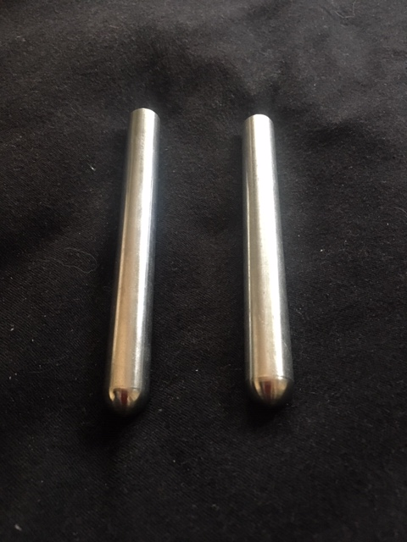
6. The rods can direct the flow of energy to any part of the body by placing the black wired rod to point 'a' and the red wired rod to point 'b'. 'a' can be the stomach and 'b' can be the back on the opposite side of the body. 'a' can be in your mouth and 'b' can be anywhere on the body. 'a' can be under your right arm and 'b' can be under your left arm. Move the rods from place to place every few minutes to avoid irritation. Any redness to the skin will disappear quickly.

7. To address cavities and gum infection, put the rods wrapped in wet paper towels, into your mouth on the lateral and medial sides of your teeth. Do each quadrant from about 5 minutes and then do the front teeth. Avoid touching the rods together as much as possible.

8. To address eye infections, put the black rod into your mouth and the red rod on the eye lid of your closed eye. This is done laying down. Be sure the paper towel on the eye lid is soaking wet. 10 minutes should be enough time unless the infection is severe as more time will be needed.

9. To address different organs of the body...put the black rod into your mouth and the red rod just below the organ. By putting the black rod into your mouth you are assured that the flow of electrons is going inside of your body. Most of the organs can be addressed by putting the red rod just above the pubic bone for a few minutes and then move it 2-3 inches to the right repeating this all the way around your body.

10. To address the whole Digestive track, put the black rod into your butt and the red rod into your mouth for about 30 minutes. This is done laying down. Lubricant is recommended to make it easier.

Plate Positioning for EarthTides

Note: Never use a metal tub. Always use plastic or glass. The plates must remain parallel and separated when the unit is on. Be careful never to arc any metal across the plates while the unit is on...like setting the plates on aluminum foil or touching both plates with metal of any kind…a spoon, a knife, a screwdriver etc etc. This will cause sparks and my damage your unit if left in this state.
………………………………………………………
EarthTides’s stainless steel plates use two bolts and two spacers to prevent the plates from touching each other. Be sure nut snug...not too tight. Hand tight is good enough.

1. You can use a clothes pin to secure the plates by securing the wire against the tub so the nylon bolts and banana plugs stay above the water.
2. You can take the plates apart to facilitate cleaning the plates and rinsing the cables where they are attached to the plates.
3. Plug the cables of the stainless steel plates into the front panel. It does not matter which cable plugs into the black or red jack. The cable that is plugged into the black jack on the front panel is connected to the plate that will be oxidized during that session. Over time, one plate will get smaller. Remember to plug the cable of the larger plate into the Black jack on the front panel so that the plates wear out evenly over time. Eventually the plates wear out by getting rougher and smaller. Eventually the plates get so small that the ionization process is compromised and a new set of plates is required.
4. When these plates get too small to use, you can purchase a new set with cables online at the Market Place for $68 which includes shipping anywhere in America.

Plate Assembly
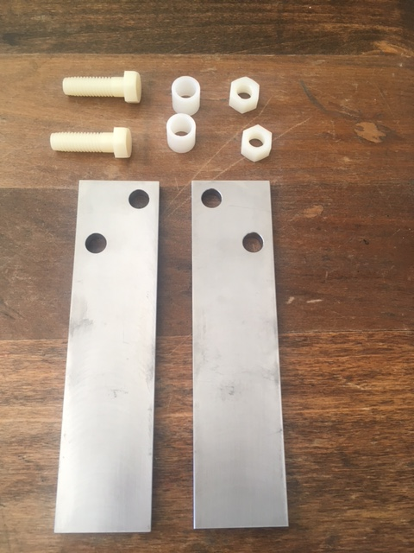

1. Place the plates as shown.

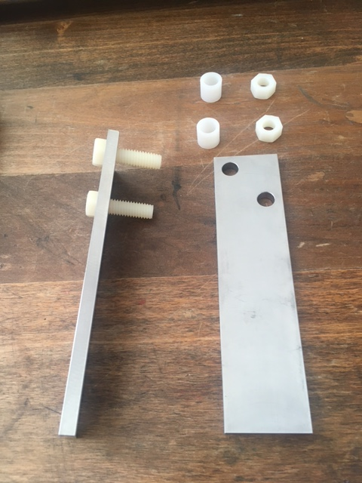

2. Flip the left plate up and to the left and insert the two bolts.

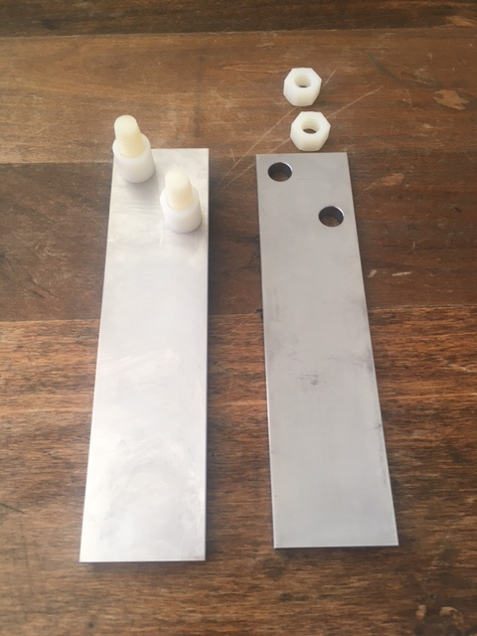

3. Insert the nylon spacers over the bolts

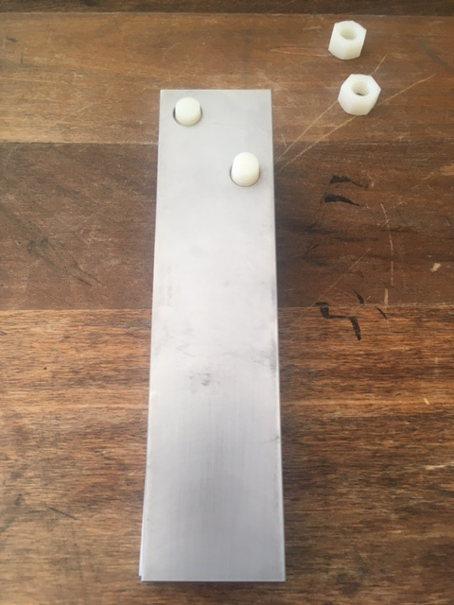
4. Insert the right plate over the bolts

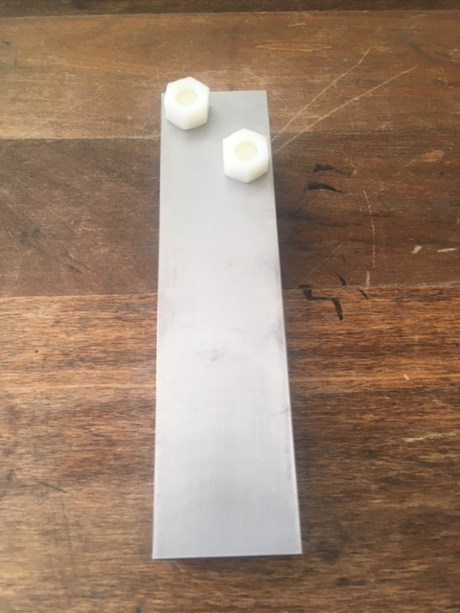
5. Put the nuts snuggly on the bolts...not too tight. Hand tight is good enough.

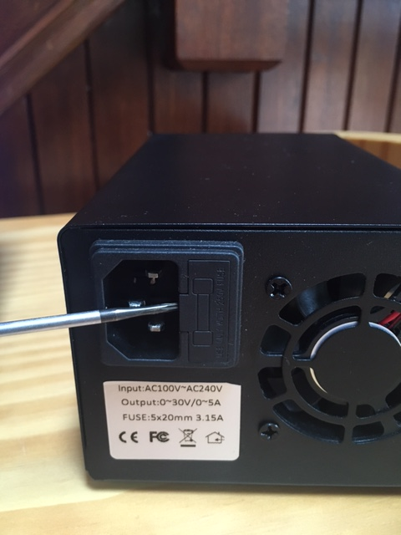
Checking and Changing the FuseFast Blow 5 Amp Fuse
5mm x 20mm
Note: A 5 Amp to 10 Amp fuse works

Simply pry out the small drawer to find the fuse. There may be
an extra fuse in the little cubby hole of the fuse holder.

Cleansing Benefits of EarthTides
As the Body is Cleansed, the body does the following things:
Increases it's cellular vitality  Boosts it's energy  Eliminates viruses like the flu  Eliminates bad bacteria  Eliminates parasites  Enhances it's immune system  Purifies it's blood  Clears the lungs  Clears the bronchials  Neutralizes bug bites  Speeds it's own healing  Improves digestion  Heightens clarity of mind  Eliminates candida  Eliminates infection  Heightens it's alertness  Detoxifies it's cells  Speeds recovery  Eliminates lactic acid  Speeds athletic recovery  Strengthens immune system | Eliminates bad microorganisms  Balances body pH acid/alkaline  Relaxes more  Purifies it's liver  Improves nerve communication  Cleans it's lymphatic system  Eliminates worms  Fights lymes disease  Fights shingles  Fights fibromayalgia  Fights Epstein Barr  Eliminates heavy metal toxicity  Eliminates chemicals  Eliminates pharmaceuticals  Eliminates alcohol buffer  Releases stress  Eliminates cavity bacteria  Eliminates gum infection  Restores gum growth  Eliminates eye infections  Clears toxic lymph nodes | Improves hormonal balance  Improves breathing  Eliminates toxins  Eliminates inflamation  Eliminates arthritis  Eliminates ring worm  Eliminates roung worms  Eliminates throat infection  Purifies it's skin  (Jot down your notes here)  ____________________________________________________________________________________________________________________________________________________________________________________________________________________________________________________________________

